SQL TASK
Task 1: Create a table named Employee Details with the following 10 columns and use
suitable constraint for every column:

-- EmployeeID (Serial)
-- • FirstName (VARCHAR, maximum 50 characters)
-- • LastName (VARCHAR, maximum 50 characters)
-- • Email (VARCHAR, maximum 100 characters)
-- • PhoneNumber (VARCHAR, maximum 15 characters)
-- • HireDate (DATE)
-- • Salary (DECIMAL, with precision 10 and scale 2)
-- • DepartmentID (Integer)
-- • IsActive (BOOLEAN)
-- • JobTitle (VARCHAR, maximum 100 characters)

QUERY:
create table employeee_details(employeeid serial,firstname varchar(50),lastname varchar(50),email varchar(100),phonenumber bigint,hiredate date,salary numeric(10,2),departmentid int,isactive bool,jobtitle varchar(100))

Task 2: Insert data into the Employee_Details Table
-- 1. Insert at least 5 rows of data into the Employee_Details table created in Task 1.
-- 2. Use meaningful data for each column, making sure the EmployeeID is unique, Salary is
-- realistic, and the HireDate is in a valid date format.
-- 3. Write the SQL queries to insert the data

QUERY:
insert into employeee_details(firstname ,lastname ,email ,phonenumber ,hiredate ,salary ,departmentid ,isactive ,jobtitle )

VALUES('harsh','kohale','harshkohale@gmail.com',957846214,'2026-04-06',10000000.00,26,TRUE,'productive'),
('priya','shahu','priyashahu@gmail.com',957846215,'2026-03-18',61000000.00,27,TRUE,'productive'),
('rohit','pandey','rohitpandey@gmail.com',957846216,'2026-03-25',11000000.00,28,TRUE,'productive'),
('kartik','mohadikar','kartikmohodikar@gmail.com',957846217,'2026-03-30',10000000.00,29,TRUE,'productive'),
('akshay','balpandey','akshaybalpandey@gmail.com',957846218,'2026-04-02',15000000.00,30,TRUE,'productive')
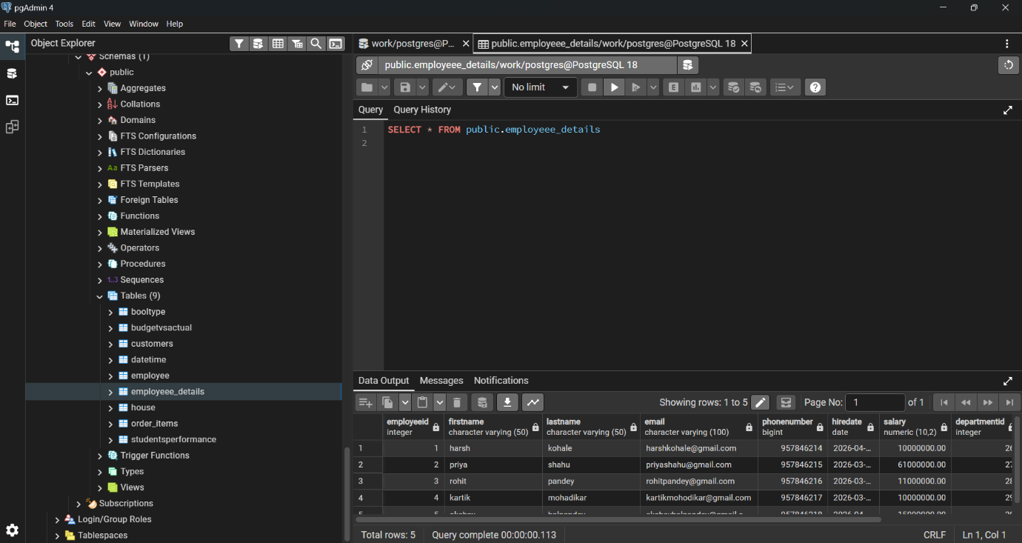

Task 3: Insert Data from a CSV File into the SQL Table
1. Insert data from a CSV file into the existing Employee_Details table that you created in
Task 1.

QUERY:
copy Employeee_Details from 'E:/sql practice/excel files/Employee_Details.csv'delimiter','header csv
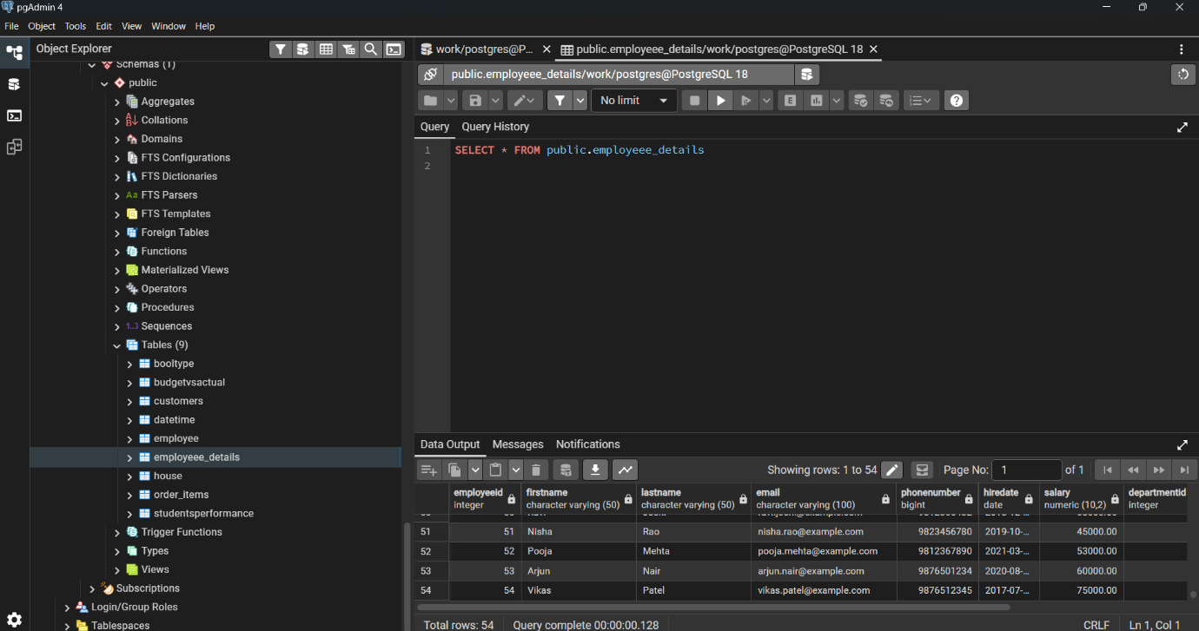

Task 4: Update the Employee_Details Table
1. Update the EmployeeDetails table by setting the DepartmentID to 0 for all employees
where IsActive is set to False.

QUERY:

UPDATE Employeee_Details set departmentid=0 where isactive='False'
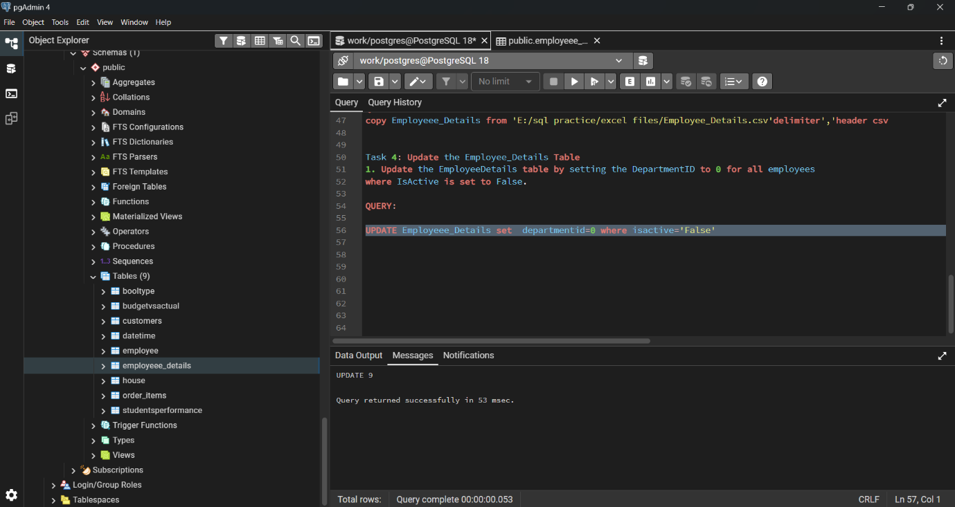

Task 5: Update the Employee_Details Table - Salary Increment
1. Increase the Salary by 8% for employees who meet the following conditions:
• IsActive = False
• DepartmentID = 0
• JobTitle is one of the following:

QUERY:
update Employeee_Details set salary=salary*1.08 where departmentid=0 and isactive='False' and jobtitle in ('HR Manager',' Financial Analyst','Business Analyst','Data Analyst')
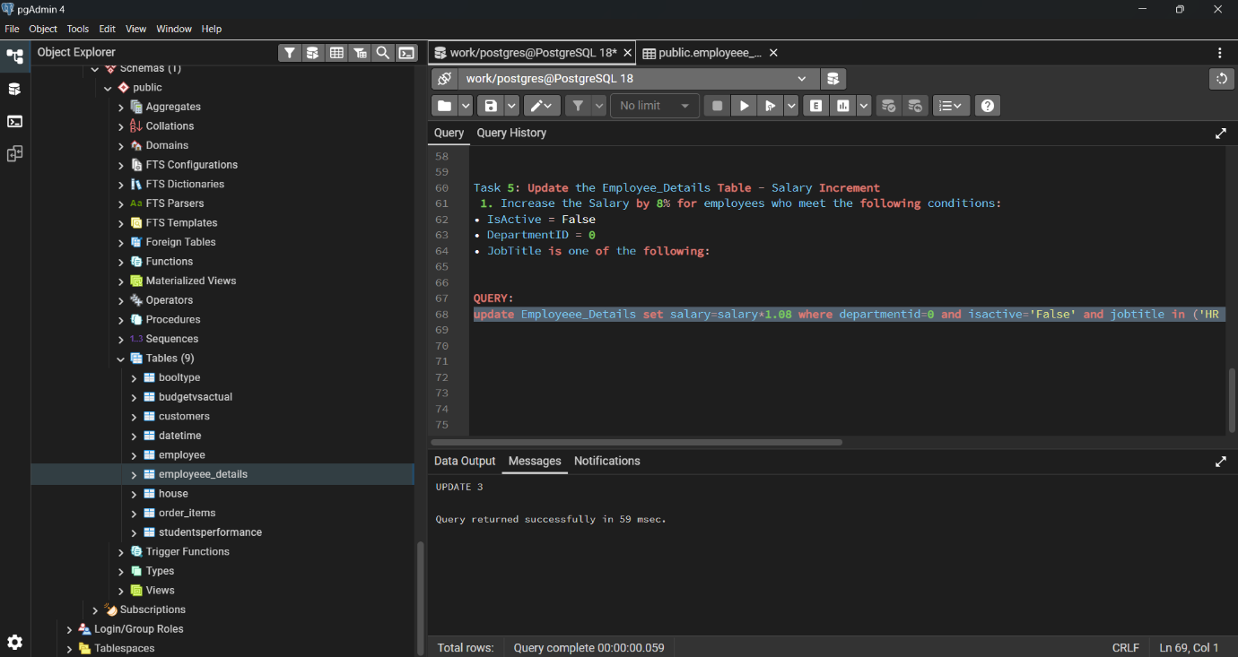

Task 6: Query to Find Employees with Custom Column Names
1. Retrieve the FirstName and LastName of employees whose Salary is between
30,000 and 50,000 and display the results as Name (for FirstName) and Surname (for
LastName)

QUERY:
SELECT firstname as name,lastname as surname from Employeee_Details where salary between 30000 and 50000
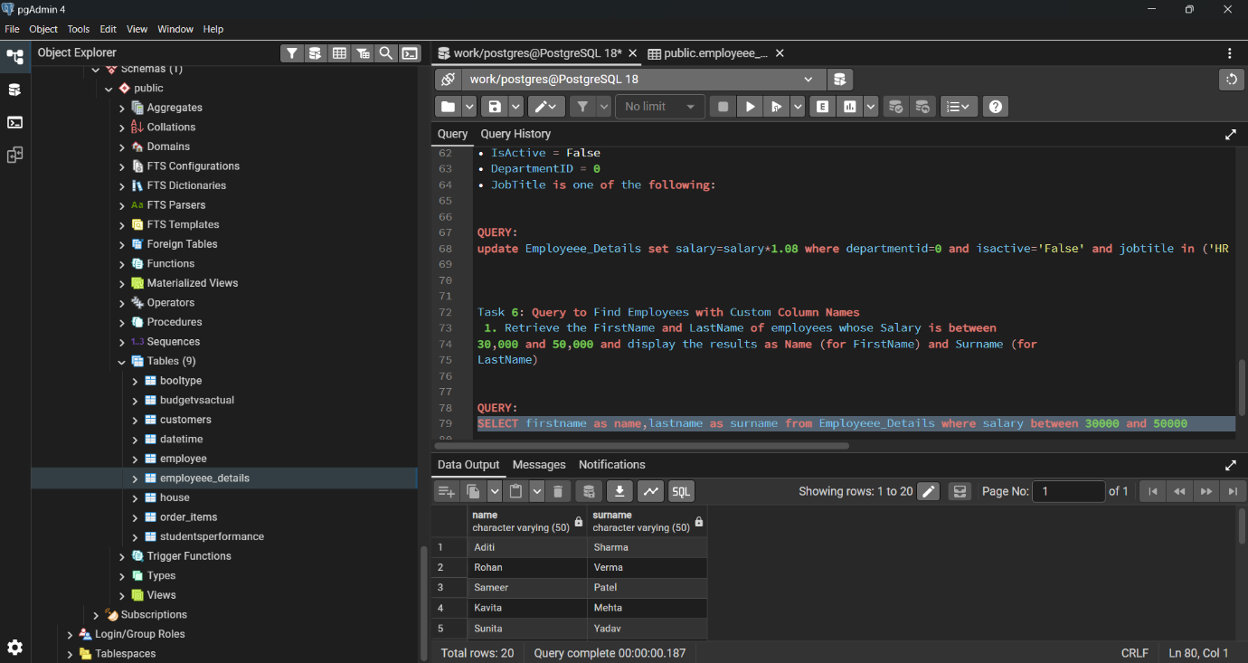

Task 7: Query to Find Employees Whose FirstName Starts with 'A'
1. Retrieve all data from the Employee_Details table where the FirstName starts with
the letter 'A'.

QUERY:
select firstname from Employeee_Details where firstname like 'A%'
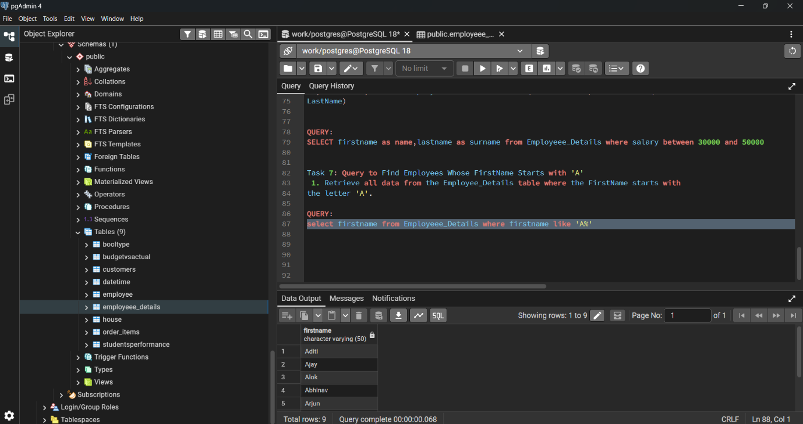

Task 8: Delete Rows with EmployeeID from 1 to 5
1. Delete the rows from the Employee_Details table where the EmployeeID is between
1 and 5.

QUERY:

select * from Employeee_Details order by employeeid offset 5
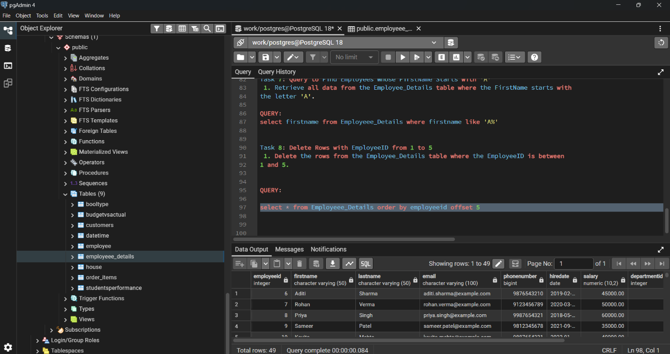

Task 9: Rename Table and Columns
1. Change the name of the table and specific column names in the existing database
structure to enhance clarity.
Instructions:
1. Rename the table from Employee_Details to employee_database.
2. Rename the columns as follows:
o Change FirstName to Name.
o Change LastName to Surname.

QUERY:
alter table Employeee_Details rename to employee_database

select firstname as name,lastname as surname from employee_database
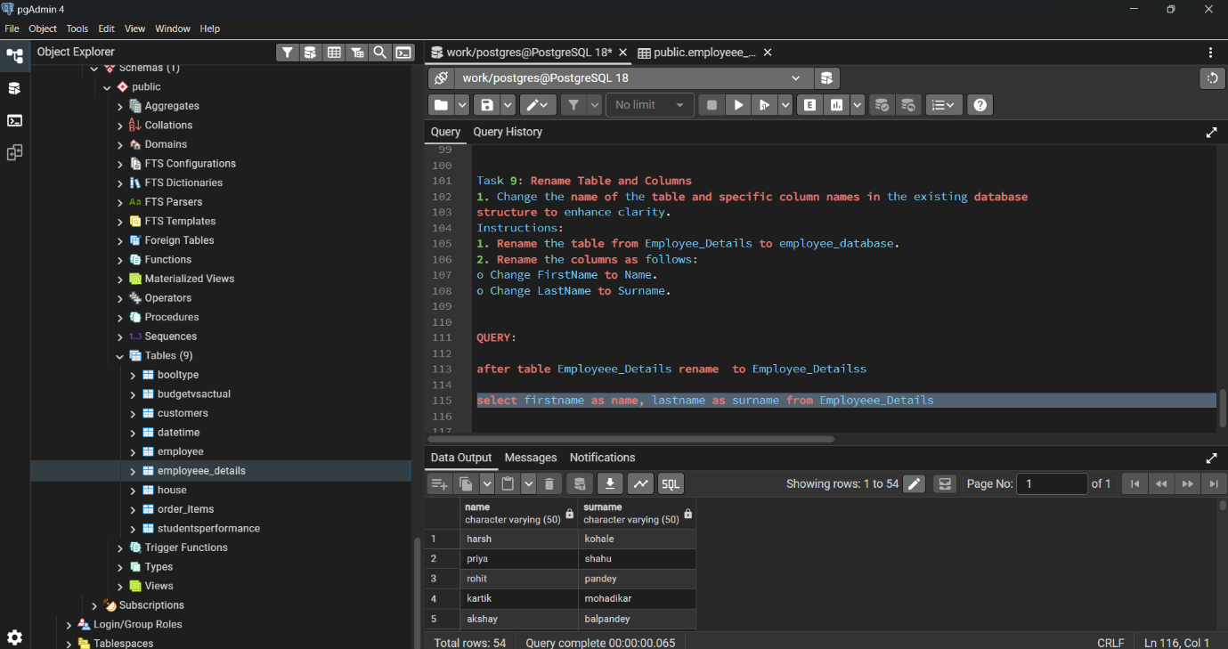

Task 10: Add State Column and Update Data in PostgreSQL
1. Enhance the employee_database table by adding a new column for State and
populating it based on the IsActive status of employees.
Instructions
1. Add a new column named State with the following specifications:
o Data type: VARCHAR
o Constraint: NOT NULL
2. Update the State column with the following conditions:
o Set State to 'India' for all employees where IsActive is TRUE.
o Set State to 'USA' for all employees where IsActive is FALSE.

QUERY:

ALTER TABLE Employee_database ADD State VARCHAR NOT NULL

update Employee_database set state='India' where isactive=True and state='USA' where isactive=False

